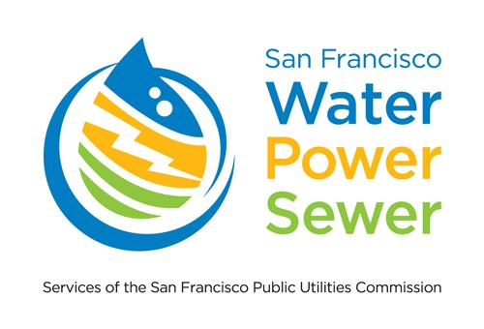
SCHEDULE R-M: MEDICAL NECESSITY ASSISTANCE PROGRAM
PROGRAM APPLICATION

PROGRAM RULES
The Medical Necessity Assistance Program provides for an increased baseline use of 75% for each of the R-1 service tiers. The program is available to residential customers served by the Power Enterprise that has an occupant at the service location who has a medical disability.

ELIGIBILITY CONDITIONS
To qualify for the Medical Necessity Assistance Program, a customer must submit an application and certify in writing that a full-time resident (the ‘qualifying occupant’) in the customer’s home is:

- Dependent on electrically powered life-support device(s) plugged into the home electric system such as an aerosol tent, pressure pad, apnea monitor, pressure pump, compressor, respirator (all types), electronic nerve stimulator, suction machine, ultrasound nebulizer, electrostatic nebulizer, inhalation pulmonary pressure breather machine (IPPB), iron lung, dialysis machine, hemodialysis machine, motorized wheelchair, or oxygen generator to sustain the life of the patient/person or to prevent deterioration of the patient/person’s medical condition; or
- A paraplegic, hemiplegic, or quadriplegic, multiple sclerosis patient, neuromuscular patient, scleroderma patient, or person with a compromised immune system being treated for a life-threatening illness that requires special electrically powered heating and/or cooling to sustain the life of the patient/person or to prevent deterioration of the patient/person’s medical condition.

Application for the Medical Necessity Assistance Program must include certification by a physician or surgeon licensed in the State of California, or by a person licensed by the State of California in accordance with the Osteopathic Initiative Act, that the person named in the application qualifies for the Medical Necessity Assistance Program.

Please allow 4-6 weeks to process your application. Incomplete applications will not be processed.

RECERTIFICATION
Unless a permanent disability is demonstrated, application for the Medical Necessity Assistance Program must be submitted annually, in accordance with the rules and procedures provided by the General Manager of the SFPUC.

TO APPLY PLEASE:
- COMPLETE AND SIGN THIS APPLICATION
- PROVIDE CERTIFICATION LETTER BY A PHYSICIAN OR SURGEON LICENSED IN THE STATE OF CALIFORNIA OR BY A PERSON LICENSED BY THE STATE OF CALIFORNIA IN ACCORDANCE WITH THE OSTEOPATHIC INITIATIVE ACT THAT A FULL-TIME RESIDENT MEETS ONE OF THE ELIGIBILITY CRITERIA
- PROVIDE PROOF THAT THE QUALIFYING OCCUPANT RESIDES AT THE ADDRESS IN APPLICATION

Customer Name (as shown on your electric bill) SFPUC Customer Electric Account Number

Service Address

Home Telephone Other Telephone

E-mail Address (optional)

Name of the Qualifying Occupant (if different from Customer Name) Relationship to the Customer

Emergency Contact Name (optional) Emergency Contact Phone (optional)

DECLARATION: By signing below, I certify that I meet all criteria listed under the Program Rules and that the information I have provided in this application and supporting documentation is true and correct. I agree to notify the SFPUC immediately of any change in my household that affects eligibility for the discount. If I fail to provide the information requested, or received the discount when my household was not eligible, I will be removed from the program and may be liable for repayment of the discount received. I understand that following enrollment, my account may be selected for random review and I agree to provide any information requested.

Customer Signature Date

Mail completed application and all supporting documentation:
San Francisco Water, Power and Sewer
Customer Services
Attention: Medical Necessity Assistance Program
525 Golden Gate Avenue, Third Floor, San Francisco, CA 94102

The SFPUC will respond to applicants with a letter indicating application status. For more information, call (415) 551-4720

